**AWS Client VPN | Simple AD**

[Client VPN with Active Directory authentication - user-based]

**Introduction**

AWS Client VPN is a fully managed remote access VPN solution used by your remote workforce to securely access resources within both AWS and on-premises network.

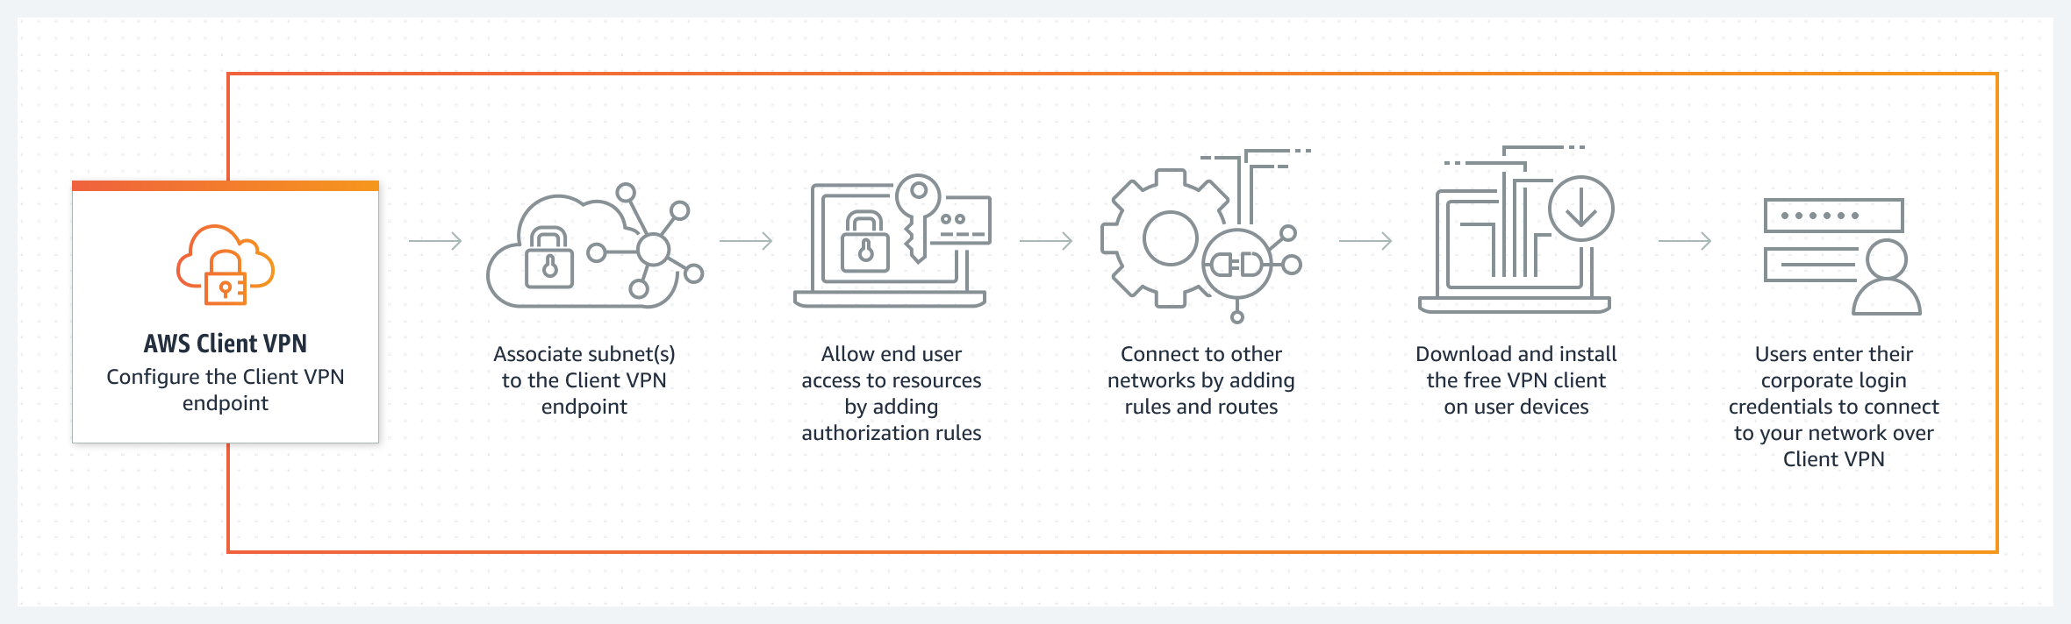

**Project Description – Scenario**

In this project I will deploy AWS Client VPN based on an AWS CloudFormation configuration template and use Active Directory services for authentication, this project intend is to demonstrates connectivity to the EC2 instance inside the VPC.

**Architecture – Overview**

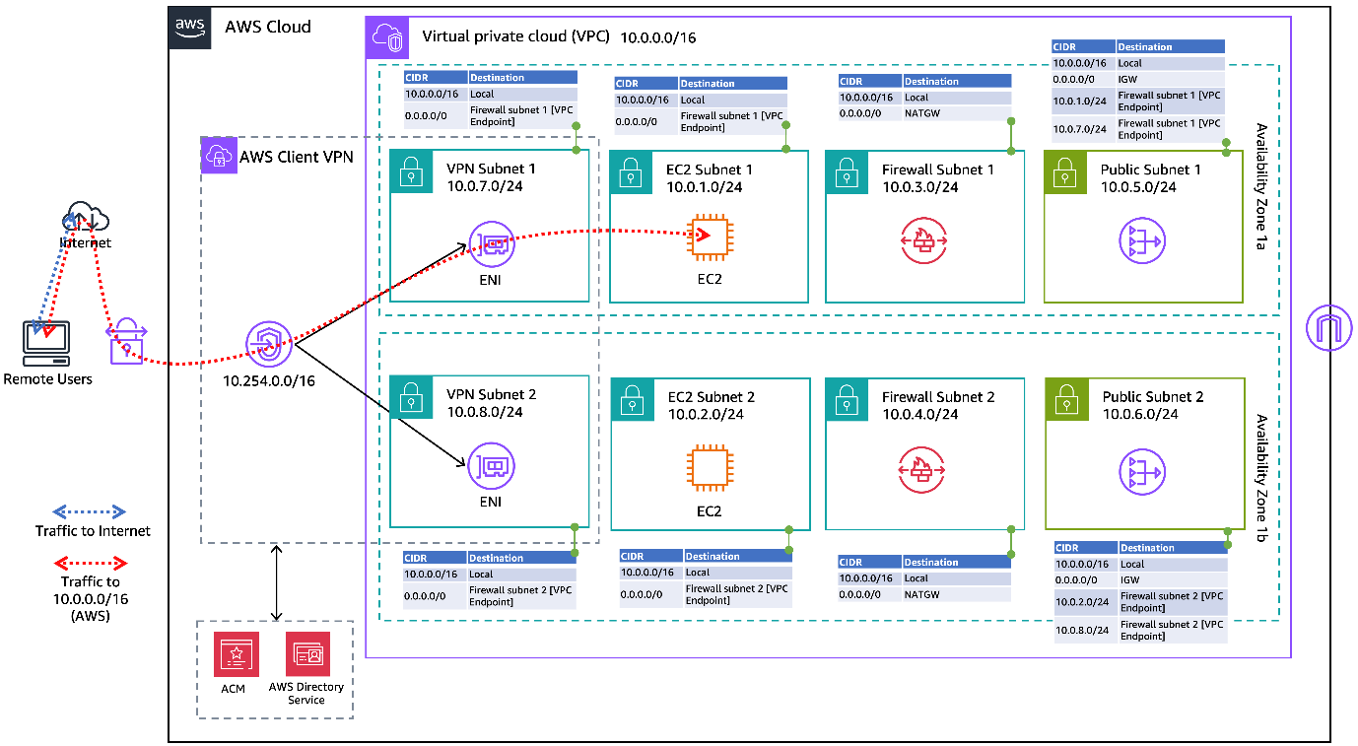

**Deploying AWS Client VPN using Infrastructure as Code [IAC]**

**Creating a Directory Service**

This enables users to sign into AWS applications such as Amazon Workspace’s and Amazon Quick Sight with their Active Directory credentials.

**Simple AD**

Simple AD is a low-scale, low-cost directory with basic Active Directory compatibility. You can use it as a stand-alone directory in the AWS Cloud to support AWS applications and services, support Samba 4–compatible app

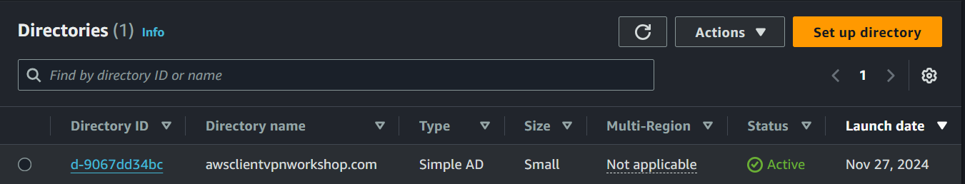

**AWS Client VPN endpoint Setup**

Creating a Client VPN endpoint will allow your clients to establish a VPN session.

**Client VPN endpoint configuration file – download and prepare file**

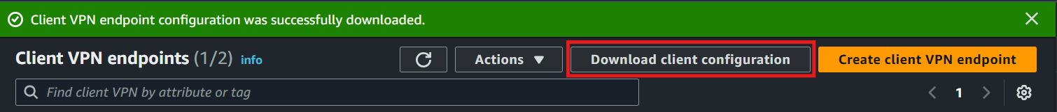

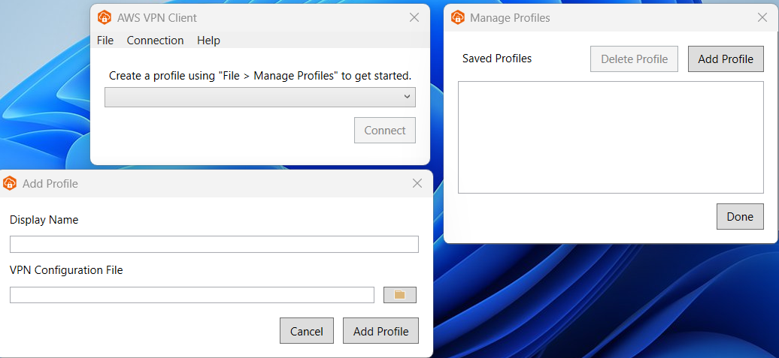

In this part I used the EC2 instance private IP address and then using AWS provided client VPN to connect to the AWS Client VPN endpoint and performed a ping test to confirm connectivity to the EC2 instance inside the VPC.

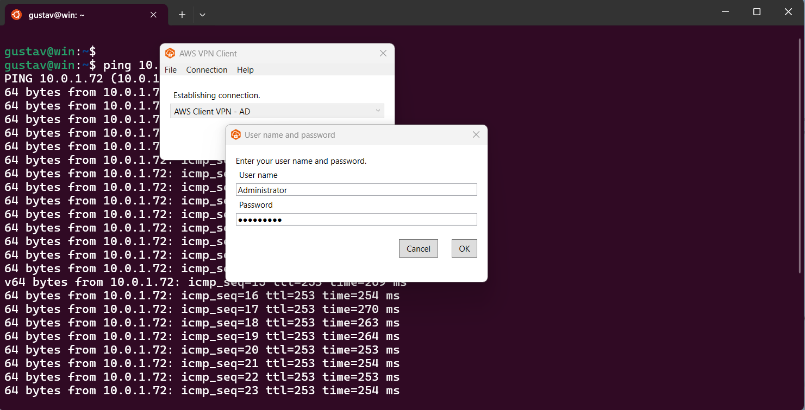

**Conclusion | Recap**

 I generated RSA certificates and uploaded them to ACM. Then setup a Client VPN endpoint, download configuration file and then used AWS provided client VPN software to connect to AWS Client VPN endpoint.

**Done!**